**ExampleStack Manual**

# Section I. Overview

Developers often resort to online Q&A forums such as Stack Overflow for filling their programming needs. Online Q&A forums have accumulated a large number of code examples that developers can reuse code from. However, such curated code examples are often incomplete and inadequate for the local context of the developers; adaptation of those examples is necessary to integrate them to production code. As a consequence, the process of adapting curated examples is done over and over again, independently, by multiple developers.

The goal of our Chrome extension, ExampleStack, is to guide developers to adapt and customize online code examples to fit their own contexts. ExampleStack has two main functions: for a given SO example, (1) it shows a list of similar code snippets in GitHub, and (2) it presents an adaptation-aware template lifted from those snippets by identifying common, unchanged code, as well as the hot spots where most changes happen. Developers can interact and customize these lifted templates by selecting desired code options to fill in the hot spots.

# Section II. Tool Features

## Detect similar GitHub code fragments.

Given a Stack Overflow post, a user can click the ExampleStack icon (see Figure 1) in the right-top toolbar of the Chrome browser to detect GitHub code fragments that are similar to the SO code example.

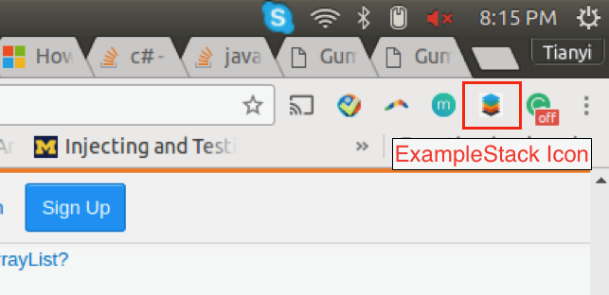

Figure 1. Click the tool icon to detect similar GitHub code fragments.

ExampleStack then highlights the parts of the SO code example that have similar code (i.e., clones) in GitHub. Figure 2 shows [a Stack Overflow post](https://stackoverflow.com/questions/37273498/add-lat-and-long-to-arraylist/37273871#37273871) that demonstrates how to read the location asset file in Android. The highlighted snippet has similar code in GitHub.

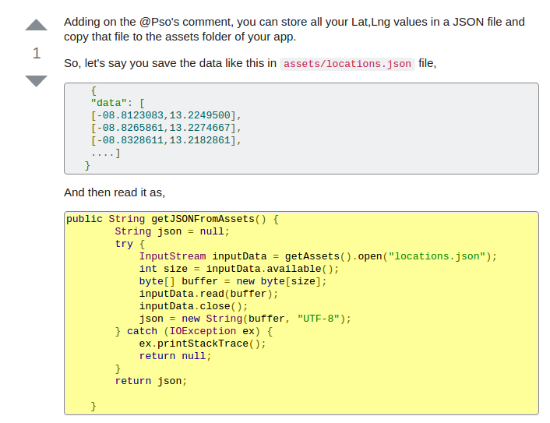

Figure 2. Highlight the SO code example that contains similar code in GitHub.

## Display similar GitHub code fragments.

A user can click the highlighted code to display similar GitHub code fragments detected by our tool. The clicked code is surrounded with a red dashed box to indicate the current focus. The detected similar GitHub code snippets (i.e., clones) are displayed at the right side of the Chrome browser. Each GitHub clone is also accompanied with its GitHub link and the number of watches, stars, and folks of the GitHub repository.

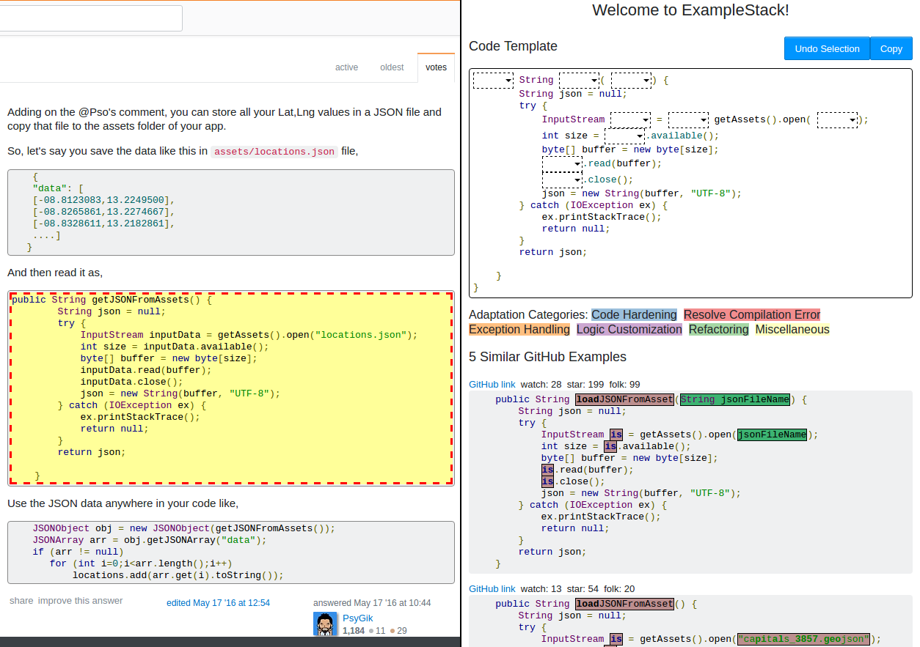

Figure 3. Display similar GitHub code snippets (i.e., clones) in a sidebar.

## Browse GitHub clones with differences.

In Figure 3, ExampleStack highlights each GitHub clone to show its differences from the original SO code example. A user can further inspect the detailed program differences in a side-by-side manner by clicking on the GitHub clone of interest. The original SO snippet is also highlighted with the differences with respect to the clicked GitHub clone.

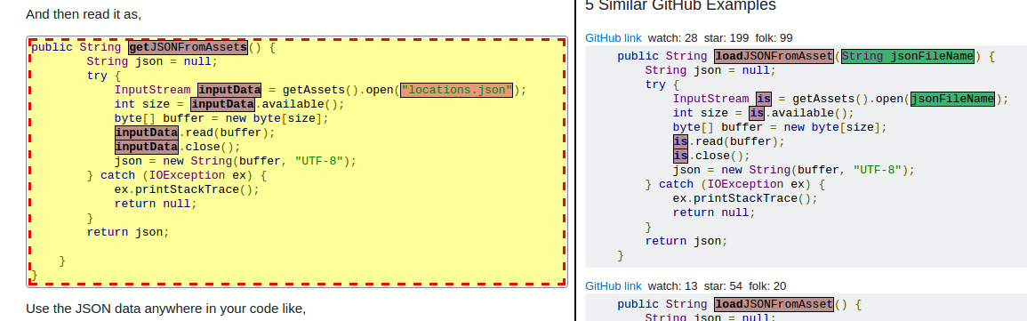

Figure 4. Inspect program differences between a SO code example and a corresponding GitHub clone in a side-by-side manner.

## View the adaptation options in a code template.

ExampleStack generates a code template to help developers obtain a comprehensive view of possible adaptation options, indicated from the variations between the original SO code example and corresponding GitHub clones. 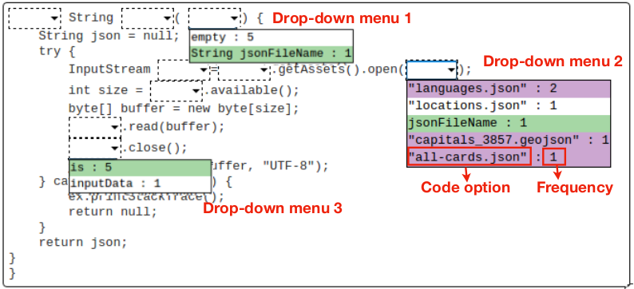

Figure 5. A code template that lists the possible adaptation options indicated by the variations between a SO code example and the corresponding GitHub clones

Each adaptation option is annotated with its frequency. For example, the first drop-down menu in Figure 4 shows that one GitHub example inserts a new method argument, String jsonFileName. In addition, each adaptation option is also colored based on its high-level categories. Currently, ExampleStack supports five categories, as shown in Figure 6. For example, replacing locations.json to languages.json is considered as a logic customization, since the functionality of the code snippet is changed to read the language asset file to support multiple languages. Therefore, the languages.json option in the second drop-down menu is colored with purple.



Figure 6. Six high-level adaptation categories detected by ExampleStack

## Customize the code template with desired adaptations.

A user can select a desired adaptation option to fill in the template. For example, a user can select the is option in the third drop-down menu in Figure 5 to rename the InputStream object from inputData, to a simpler name, is. ExampleStack will automatically fill in the rest of the template with code options that are occurred with the selected option, as shown in Figure 7.

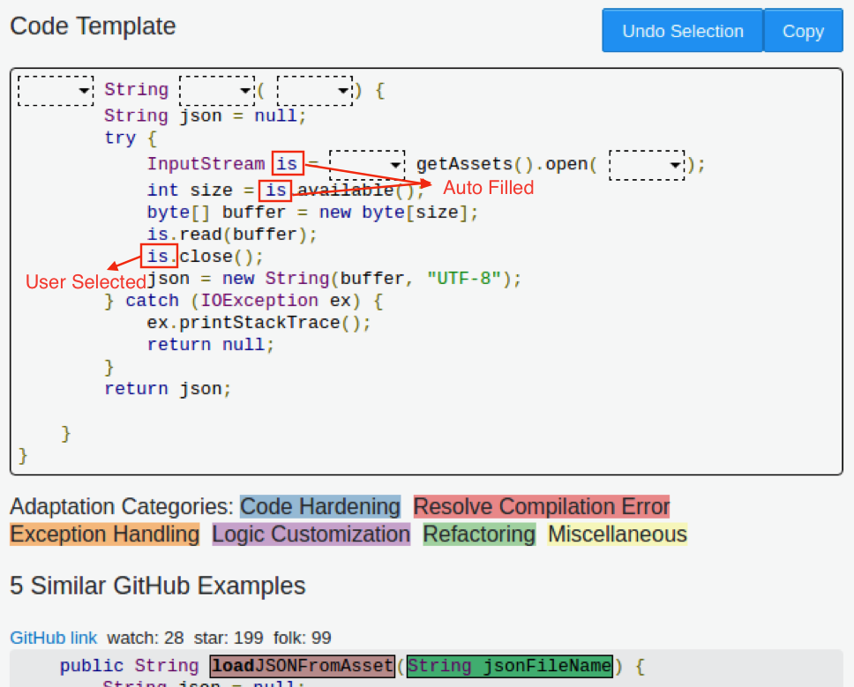

Figure 7. ExampleStack automatically fill in the rest of the template based on the user selection.